HOE TONGA PADDLER SERIES – EVENT 1

Date: Saturday 29th May 2021
Postponement date: None
Venue: On shore location Ngāti Toa Sea Scout, Pascoe Ave, Ngāti Toa Domain, Paremata
Enquiries: contact mroxnam@gmail.com, 0210318072

Note: All competitors must wear an approved personal floatation device (must be in good condition and correct size) and all Wakas must be fitted with a spray skirts.

COVID 19: This race will only take place when Wellington is operating at COVID Level 1or 0. QR codes and contact lists will be placed around the venue to ensure that people can sign in when they are on site there will be hand sanitisers on site. For your convenience tracing form will be attached to the Safety Waiver form.

Kaupapa
The Hoe Tonga Paddler Series is designed to attract new paddlers to our sport, and to enable paddlers and teams to race during the winter season. The Series is overseen by Hoe Tonga, with Race #1 of 2021 is being hosted and organised by Hawaiki Nui Tuarua Waka Ama Club.

Distances and divisions
Races consist of a long course (15-18km) for senior teams, and a shorter course (7-9km). The latter is intended primarily for junior and novice (1st year paddling) teams. The short course event is long enough to be challenging and not so long as to be daunting.

This is the first of four Hoe Tonga Waka Ama events, more details can be found at HOE TONGA PADDLER SERIES 2021 .

Participants
- Senior teams (long course): men, women, mixed, U23 to M70
- Junior teams (short course only): men, women, mixed, J16 and J19
- Novice teams (short course only): can be made up of any combination of paddlers and age groups (e.g. 5 men and 1 woman, or 4 women and 2 men). They can also include up to three senior paddlers to make up numbers (e.g. steering).
- All paddlers must be affiliated to a Waka Ama club and Waka Ama NZ

Programme
7:30am Volunteers arrive, safety boat briefing
8:00am Registration, rigging waka and safety checks
8:30am Karakia
9:00m Novice and Juniors race briefing
9:30am Novice and Juniors race start
11:00am Open race briefing
11:30am Open race start
1:00pm Pack up de-briefing

Entries
Senior paddlers are encouraged to assist novice teams (e.g., by steering) in the short course. There is no extra cost for senior paddlers also competing in the long course event.

Entries are to be done online by your NKOA coordinator via www.wakaama.co.nz
- Entry fees are non-refundable but can be transferred to a paddler in your team.
- Team entries close on Monday 24th May 2021.
- The paddler roster closes on Wednesday 26th May 2021.
- All race participants must register and attend the race brief.
- Wearing of Lifejackets and Spray skirts is mandatory

Venue and parking
On shore location Ngāti Toa Sea Scout, Pascoe Ave, Ngāti Toa Domain, Paremata.

Race waiver form & Safety Check Form: for this event is attached, please note tracing information is requested for paddlers and your guests (this is provided on the rear of your waiver form). This information will not be retained beyond the designated period and will be shredded for confidentiality purposes.

- All race participants are required to read and sign the form and hand it in at registration.
- Paddlers 18 years or under must have a parent or guardian sign the form for them.

Cancellation
Extreme weather conditions such as high wind and/or rain that jeopardise the safety of paddlers may lead to cancellation of the race. Event organisers will endeavour to inform entrants of this by 12 pm the day before the event or as early as possible on the day of the event.

Race courses
Any change to the course due to weather conditions will be notified at the race briefing.

Meal
You have a meal ticket in your race pack. This entitles you to a sausage, patties and cup of soup + tea & coffee.

Race 1 Junior and Novice Preferred Course (7-9km).
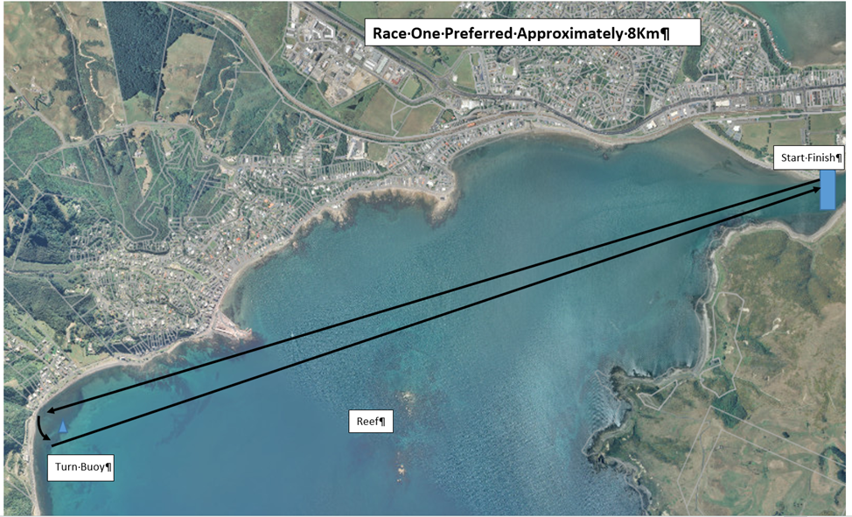

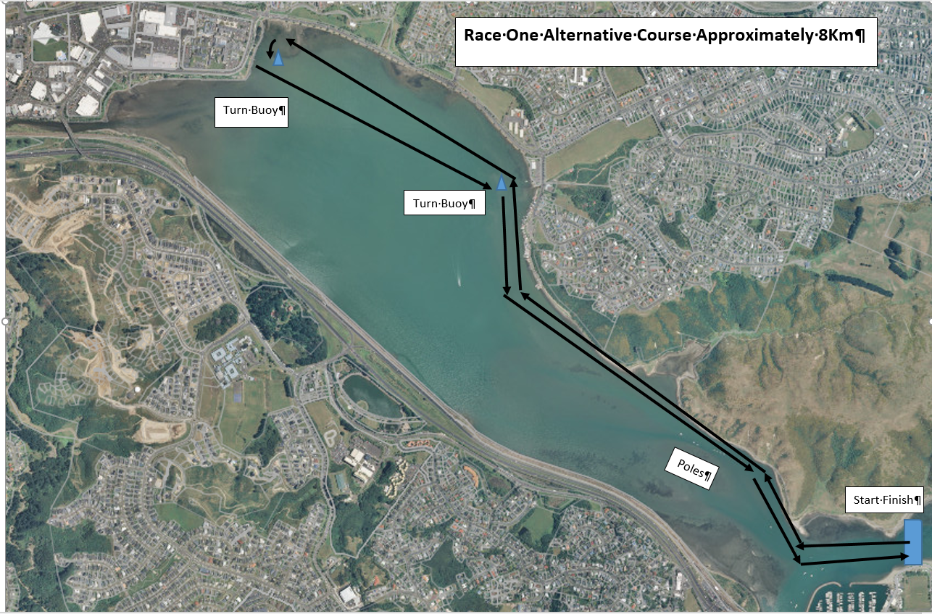
Race 1 Junior and Novice Alternative Course (7-9km).

Race 2 Open Course Preferred (15-18km).
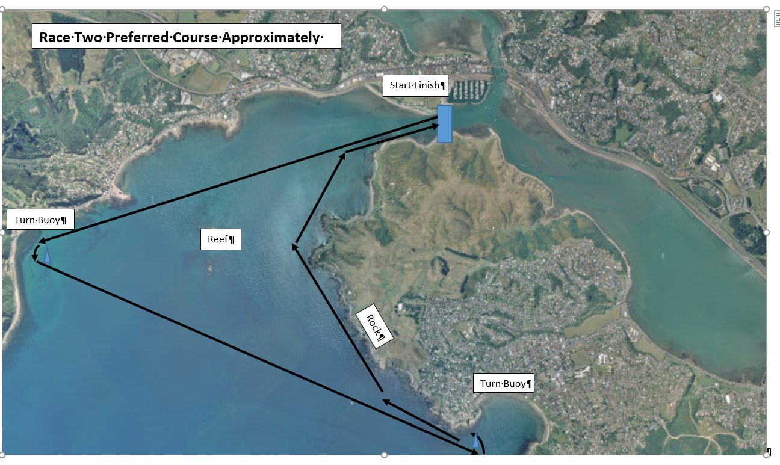

Race 2 Open Course Alternative (15-18km).
